**Name*:Aarati Bhailal Dhuriyabans**

**Batch*:Jan(Batch)2023**

**Project*:Historical Places In India**

**Problem Statement:**

Weather Forecast App

Make a web app for users to see the current weather and the weather forecast for the next 7

days.

Requirements

An input for users to type city name

Display current weather including weather condition, temperature, humidity, wind speed, and

date and time

Visualization to display the temperature change, humidity change, and weather conditions of

each day.

Suggested Implementation

Fetch user's device position. If you're unable to get the user's position, set Delhi as the

default location.

Fetch weather data (forecast data and current weather data) of the location from weather

API

Format the data into charts

Display the chart and current weather

**Github link:-** <https://github.com/AaratiDhuriyabans/WebDevelopmentMajorProject>

**Solution:**

**Index.html(home):**

Step 1:In this scenario I have added javascript ,bootstrap,font awesome libraries. And in body <body> tag loaded date and time.

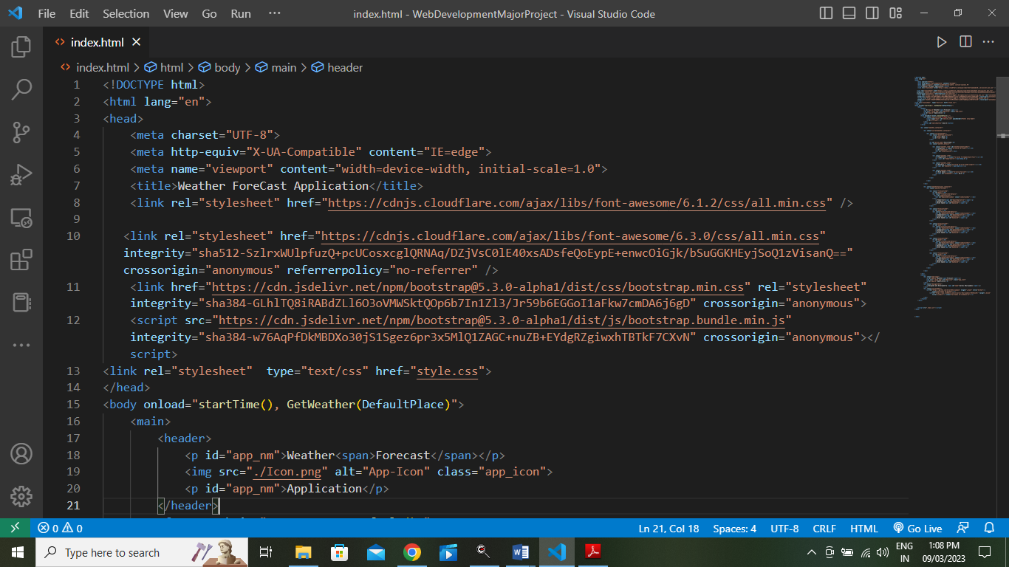

Step2: In Header <header> tag applied title as project name and then taking form <form>tag for one input <input>tag for searching city name and another <button> tag for for displaying data.

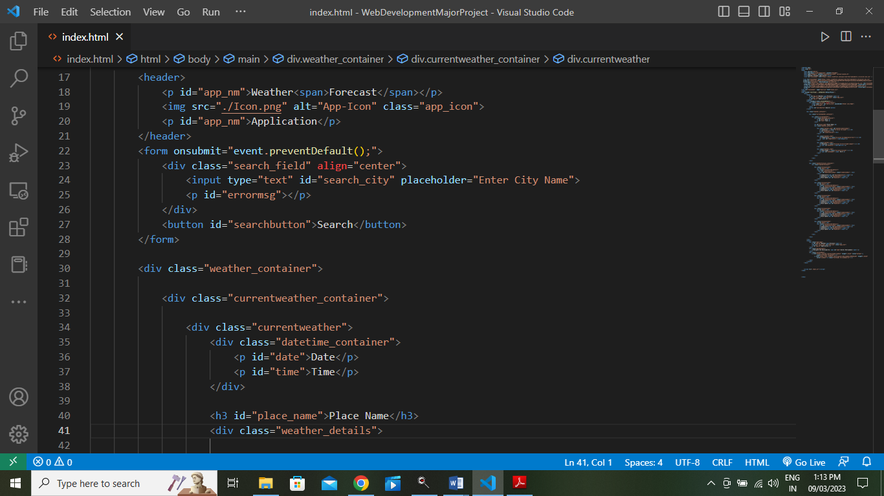

Step 3:In this scenario ,I have displayed weather details like, humidity,temperature, wind speed,date time



Step 4:Vice-versa next day of weather details also displayed.

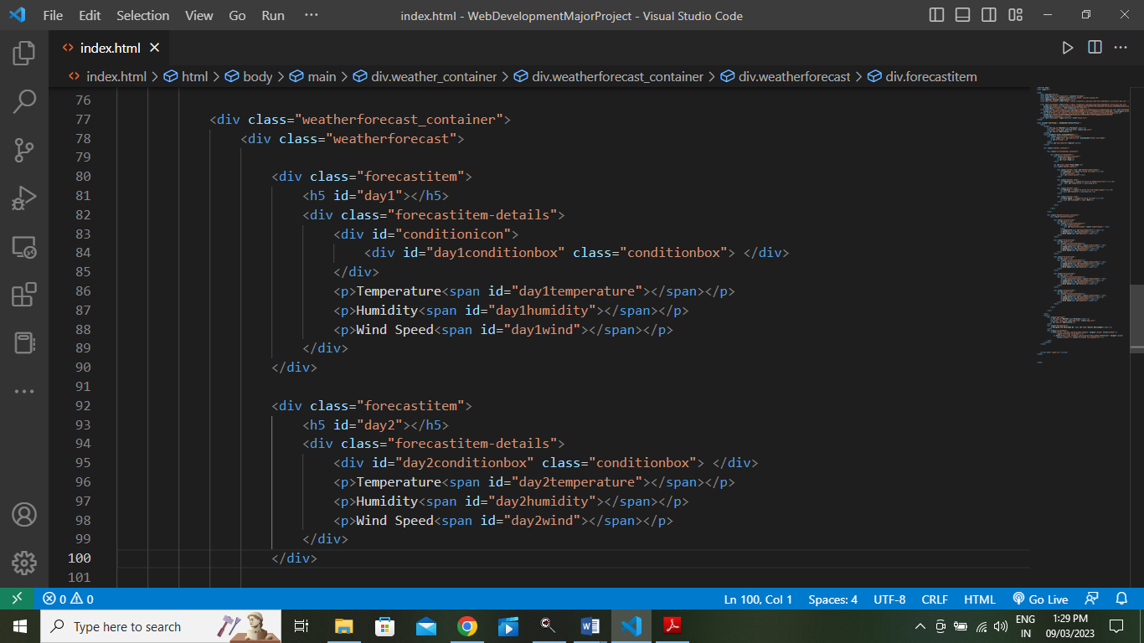

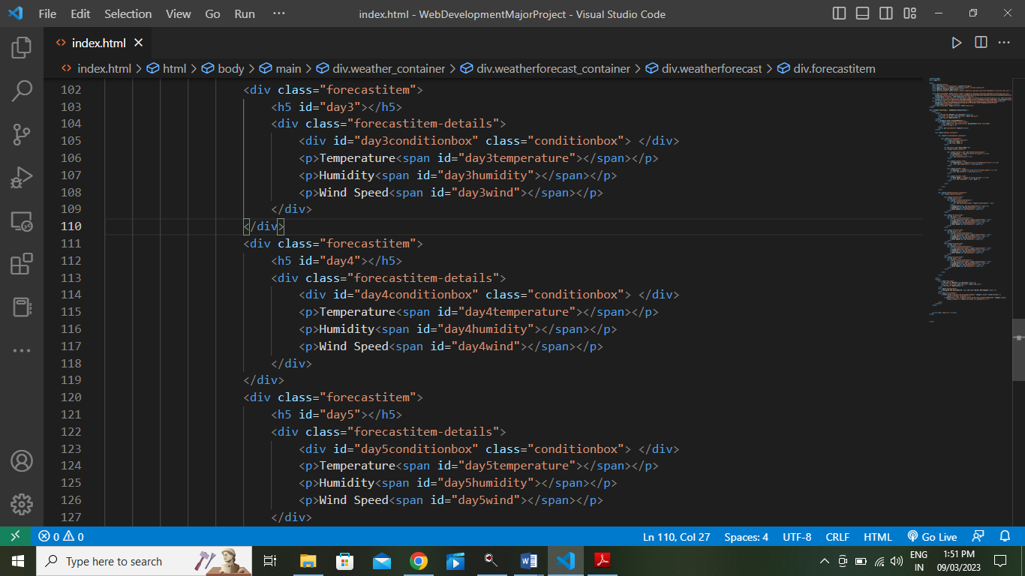

Step5:

In footer <footer>tag used tittle and designed developed by as well as social media link.

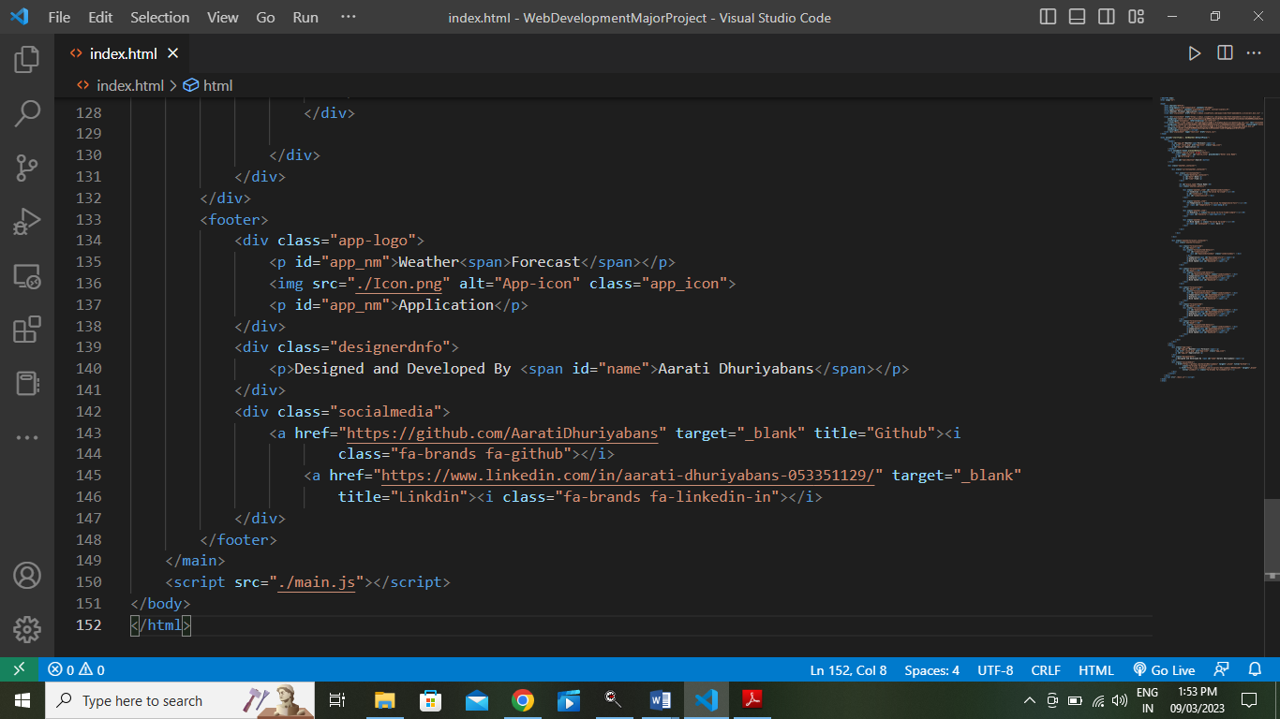

**Style.css**

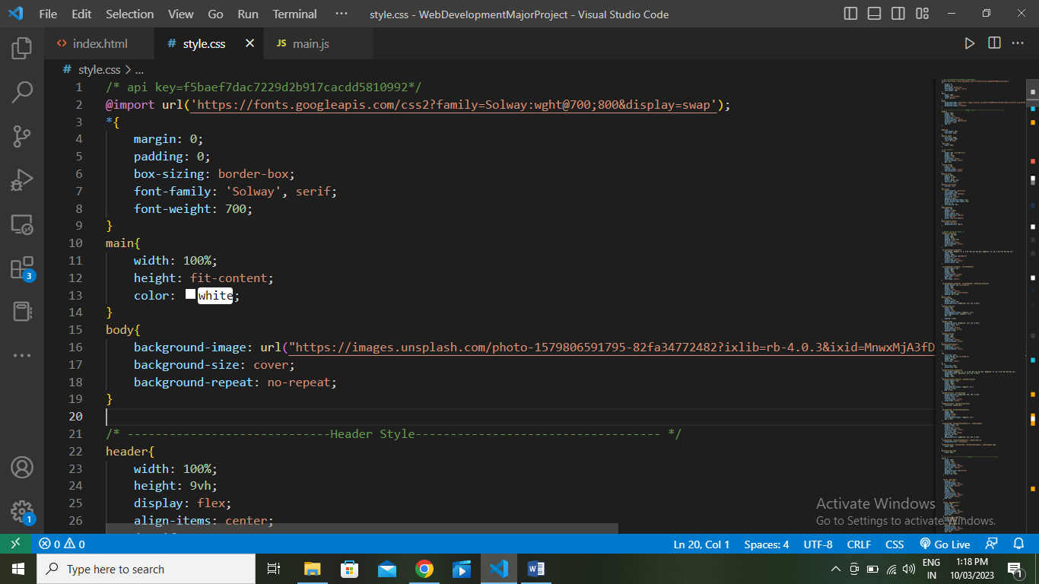

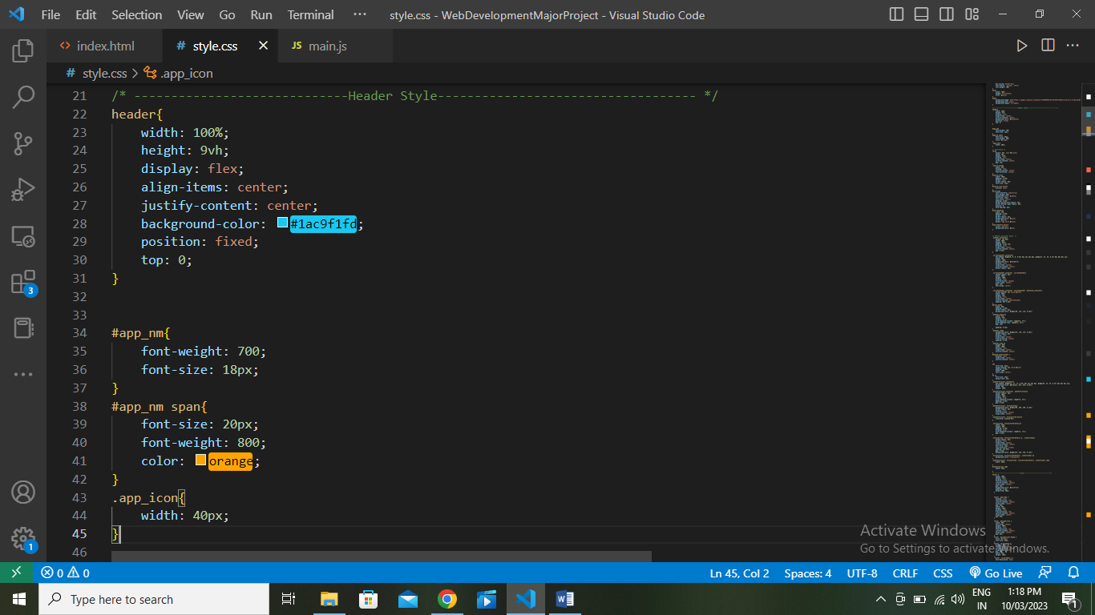

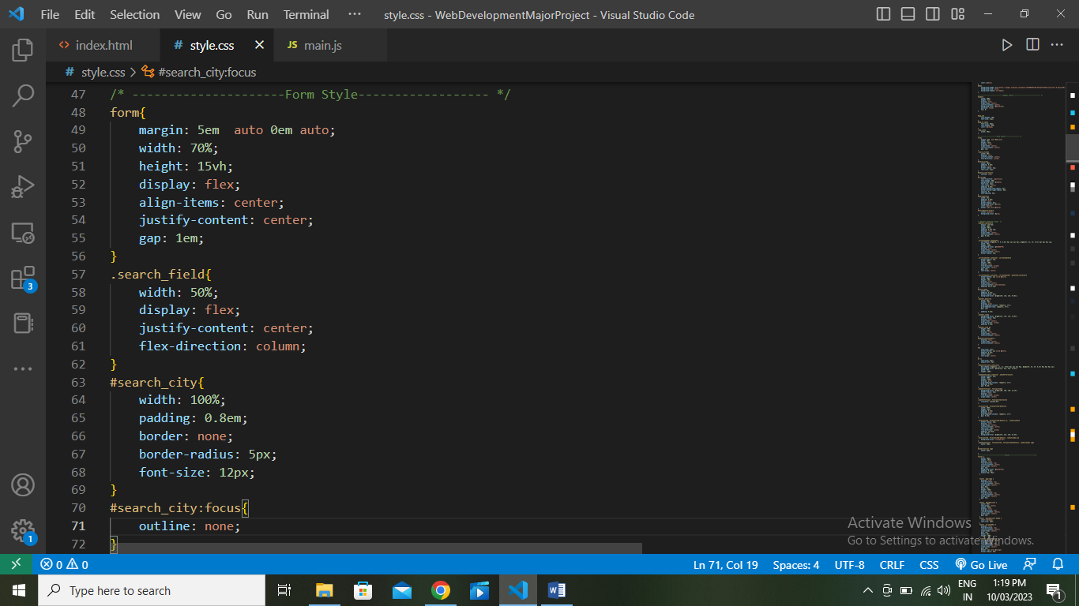

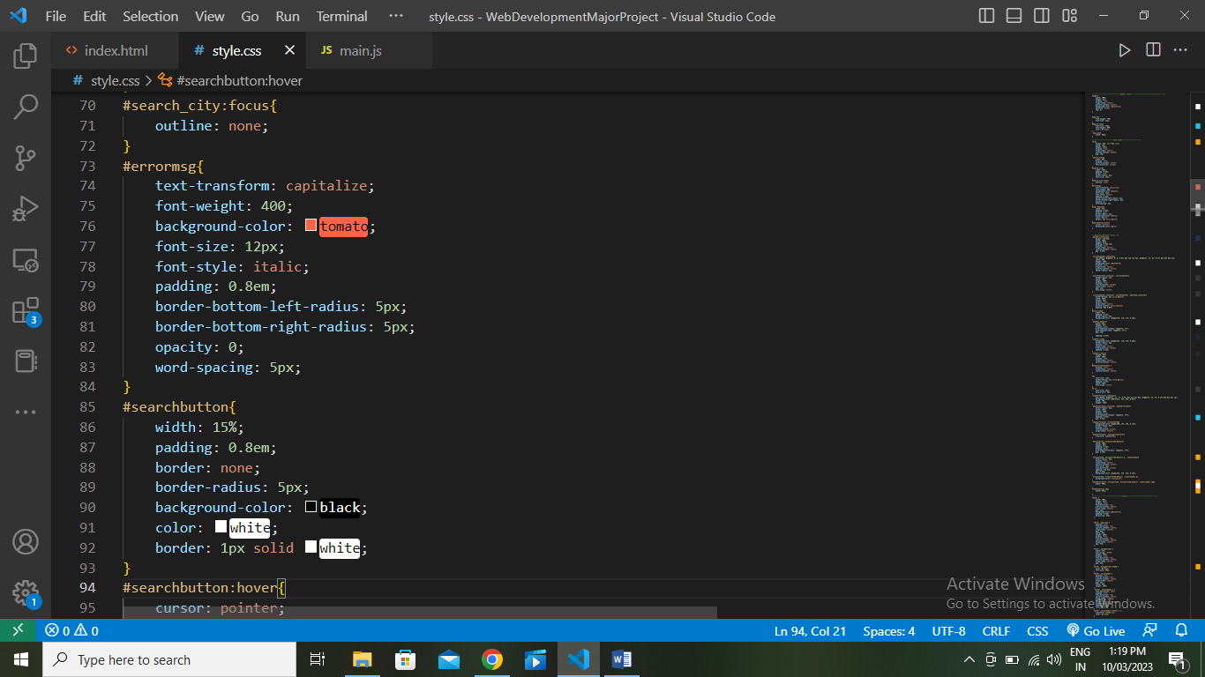

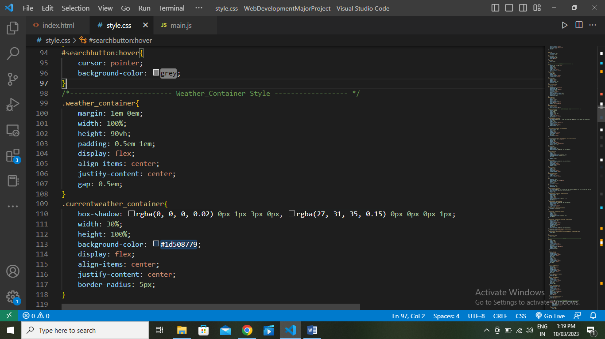

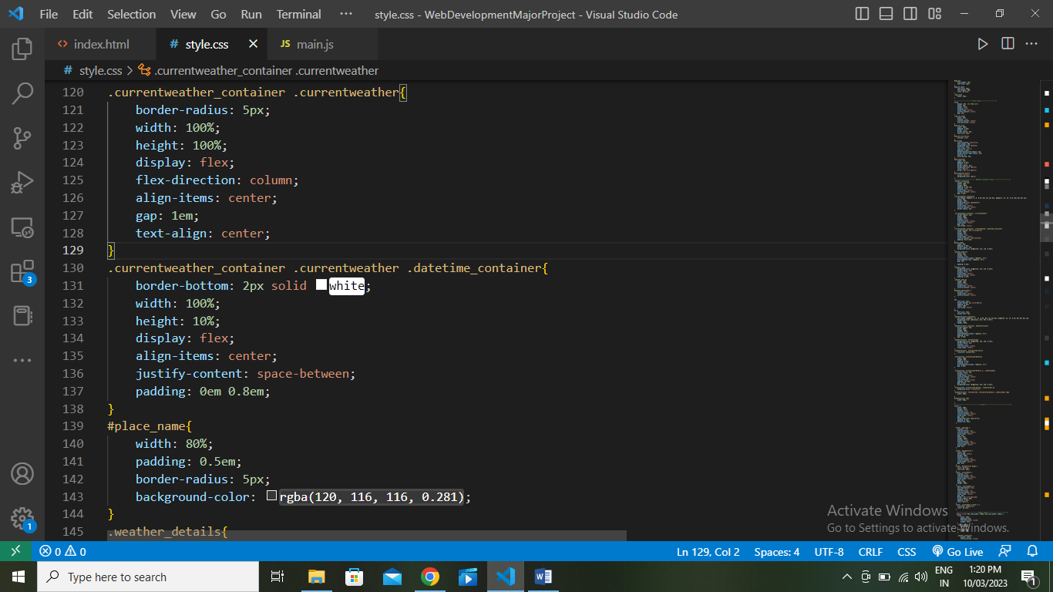

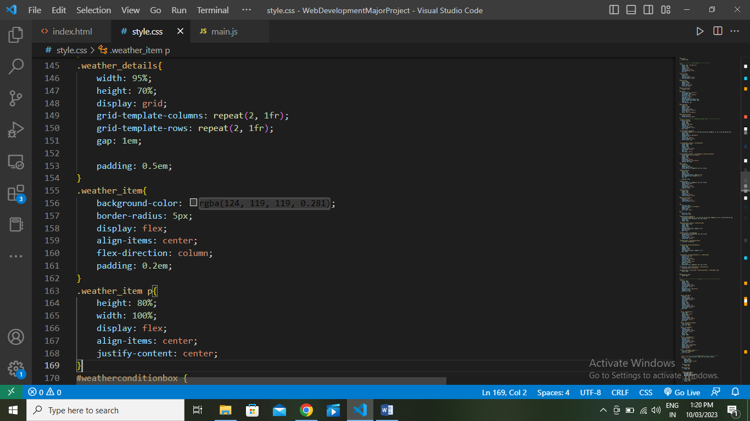

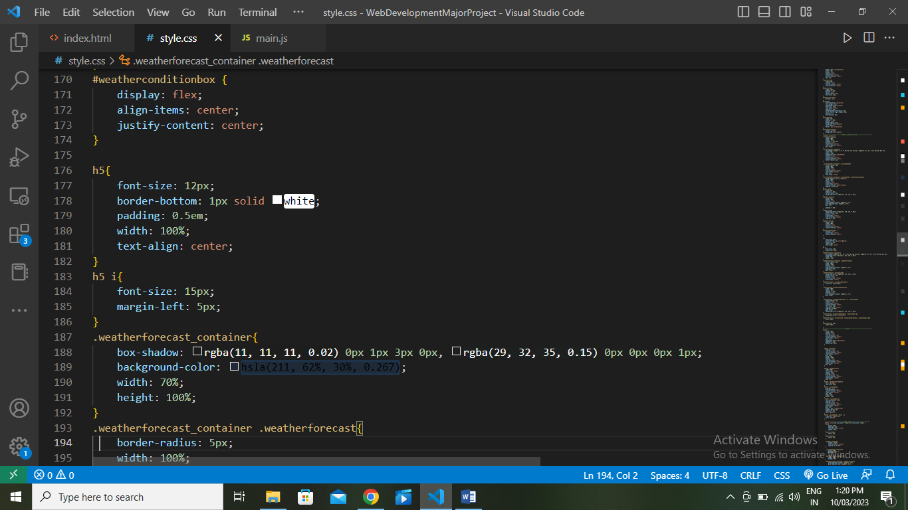

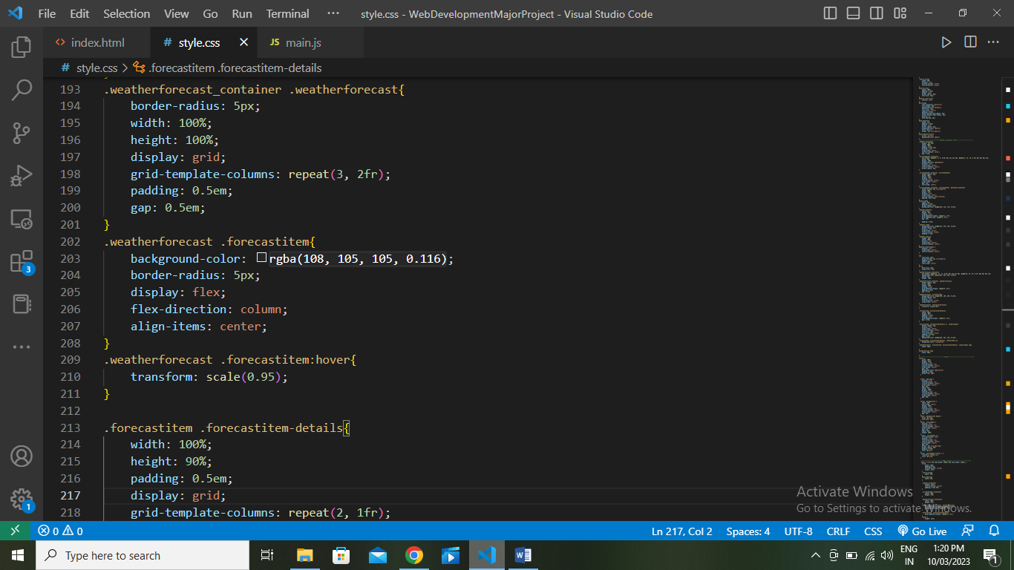

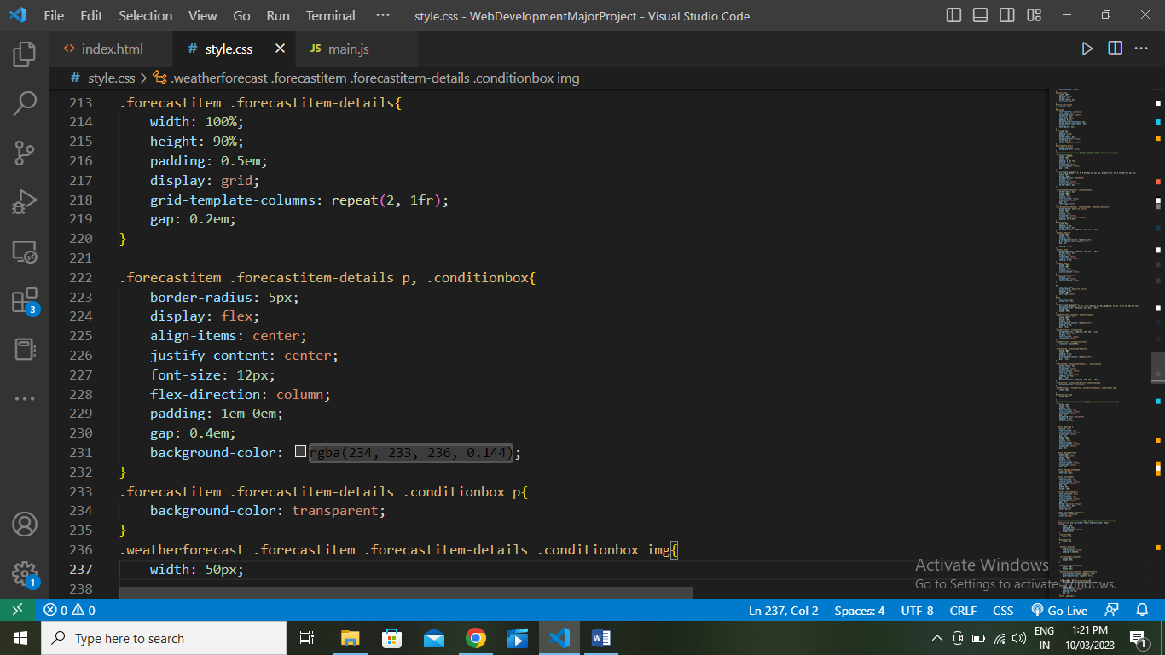

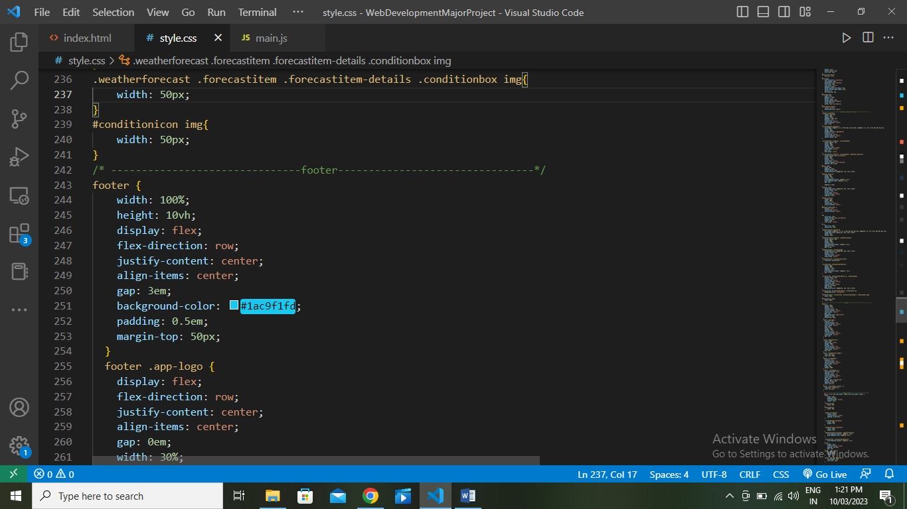

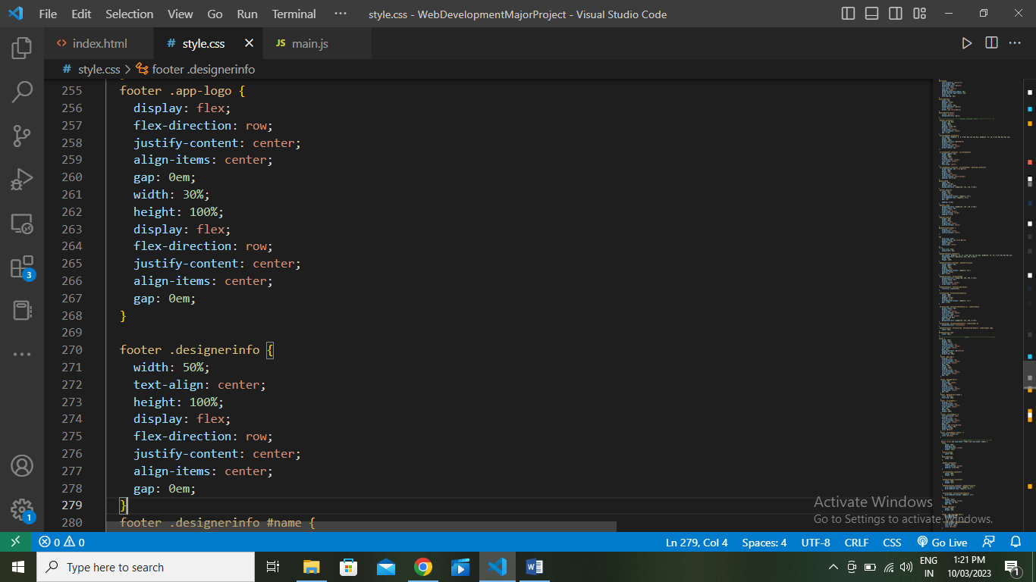

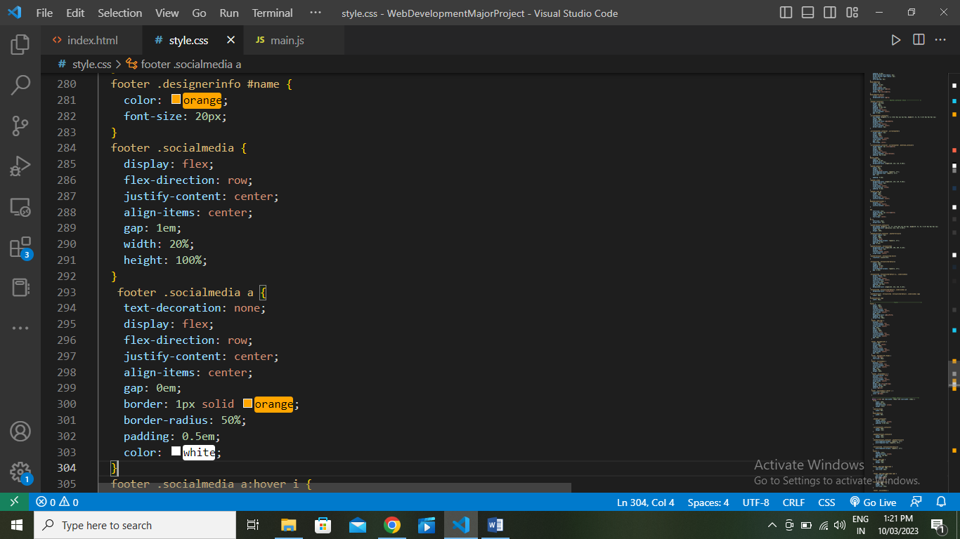

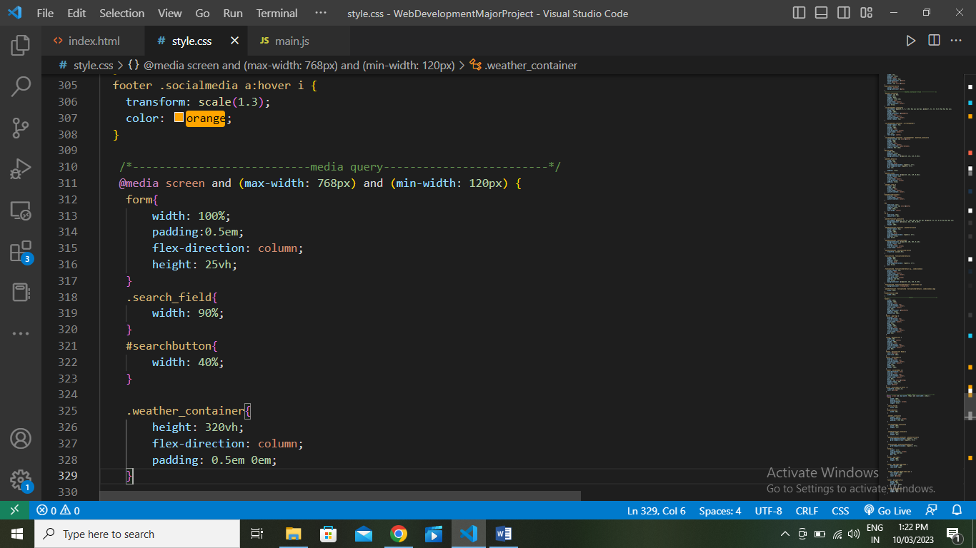

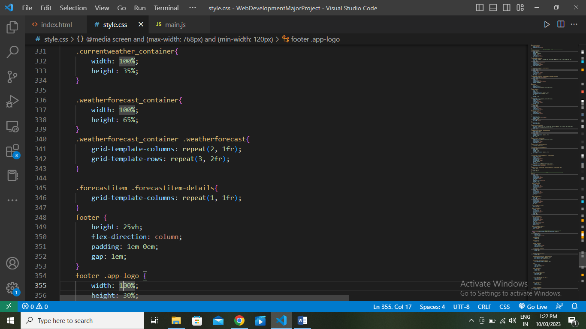

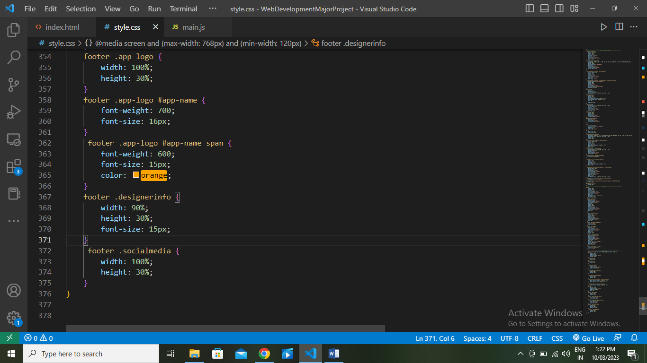

**Main.js**

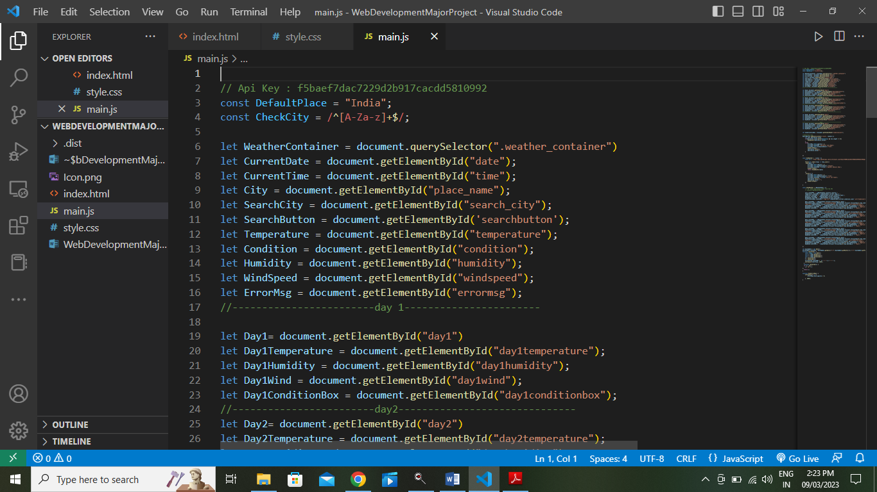

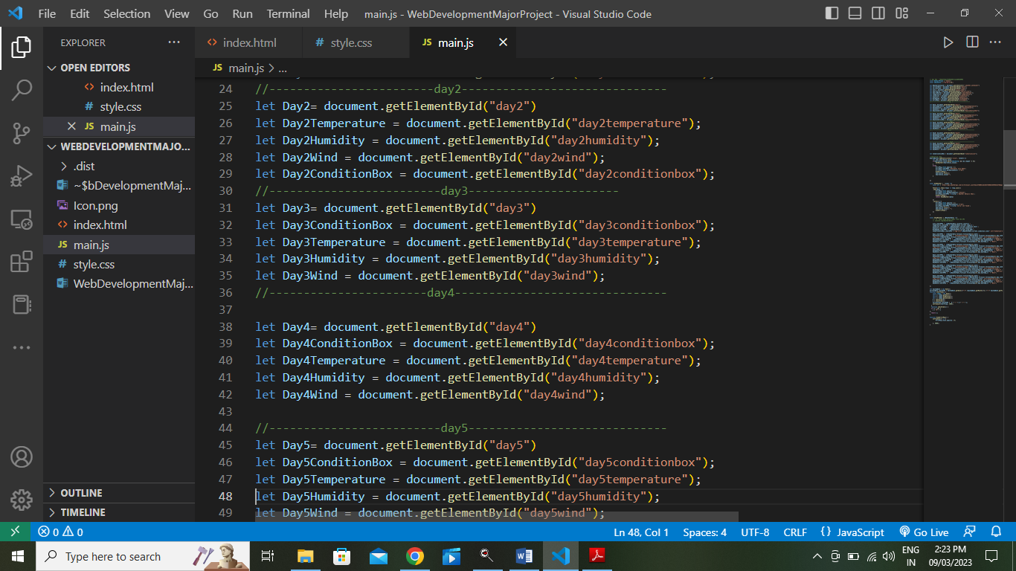

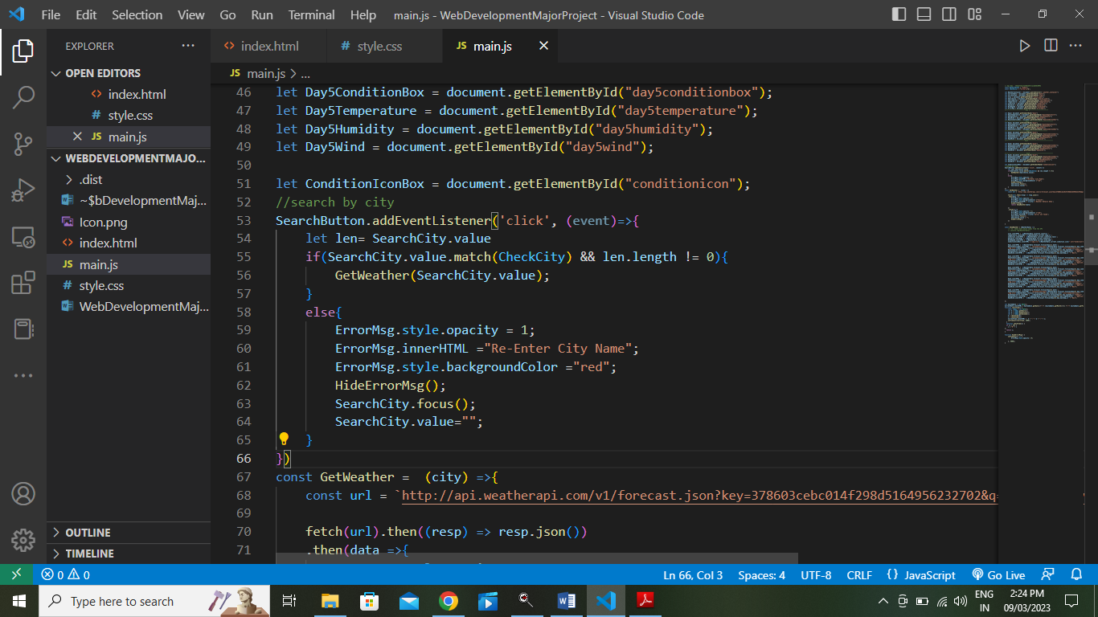

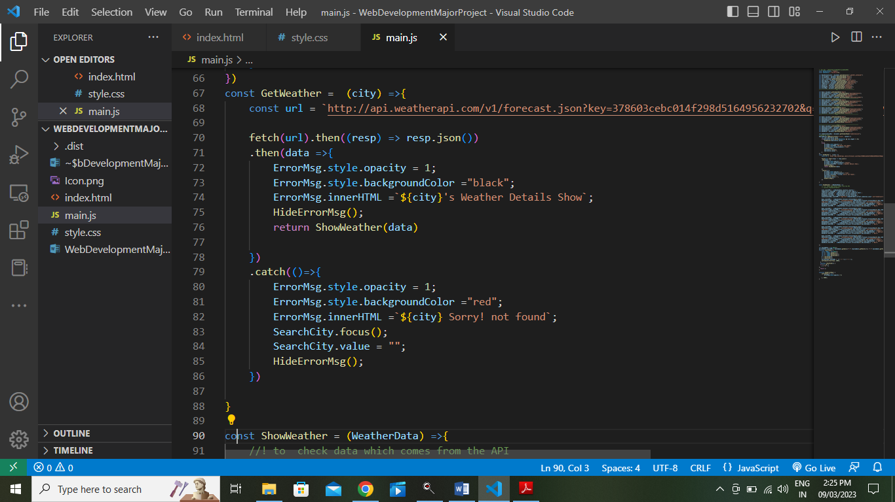

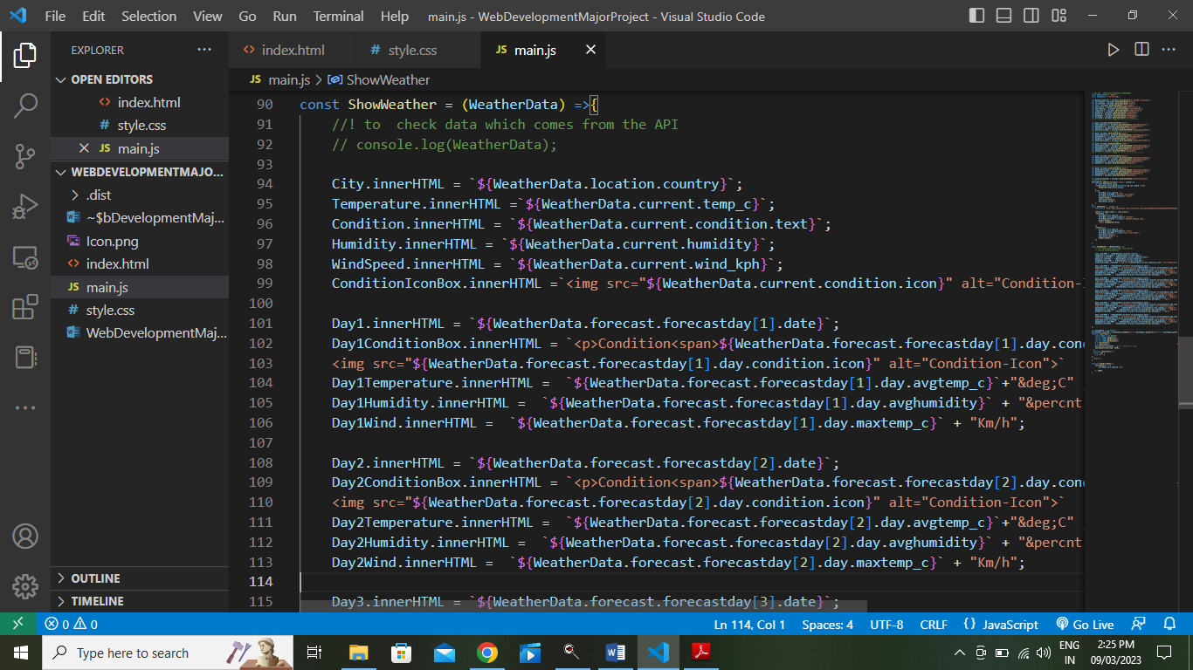

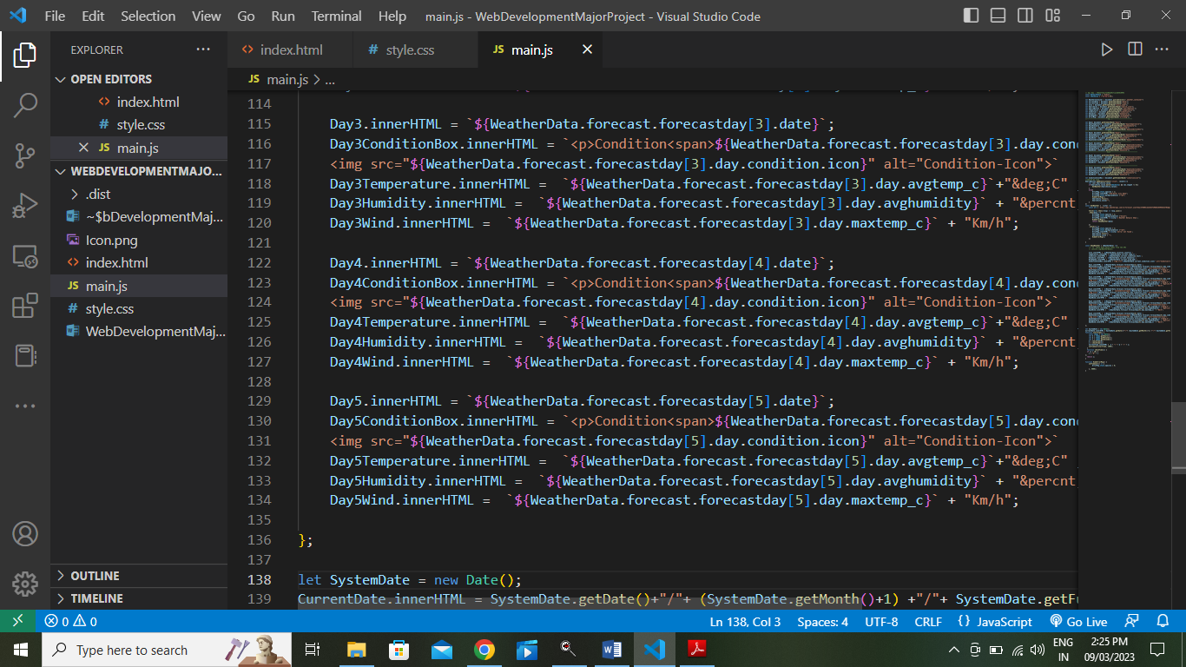

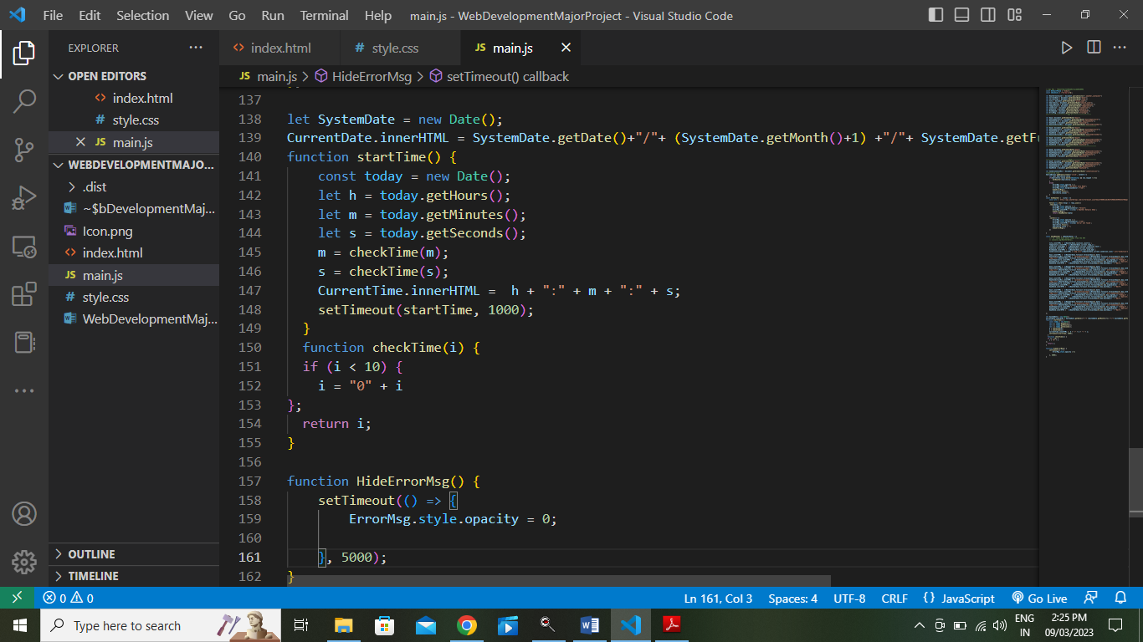

**Output:**

